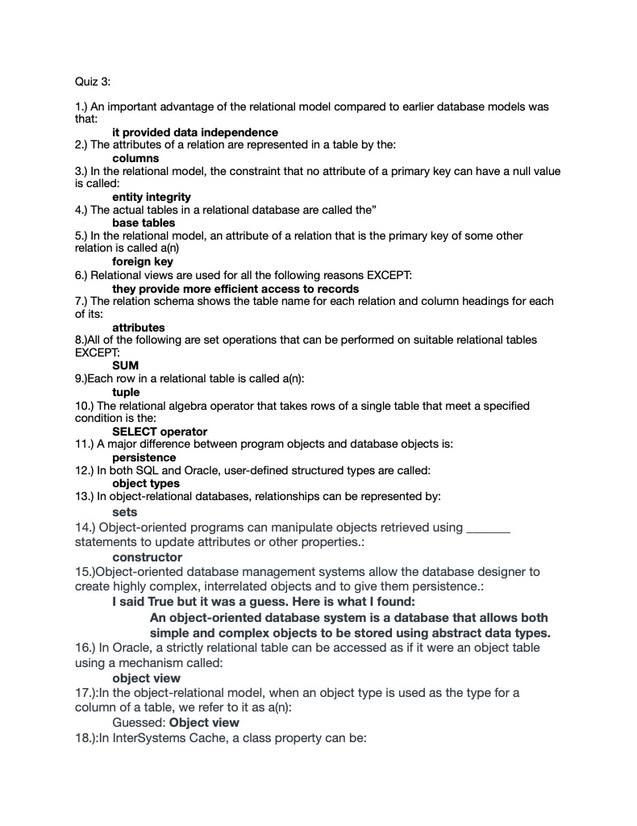

19.In the object-oriented model, if class methods have the same name but different parameter lists and/or return types they are said to be
Overloaded

20. The Object Database Management Group published standards for all the following EXCEPT
SQL

QUIZ 17/20

